Member information booklet

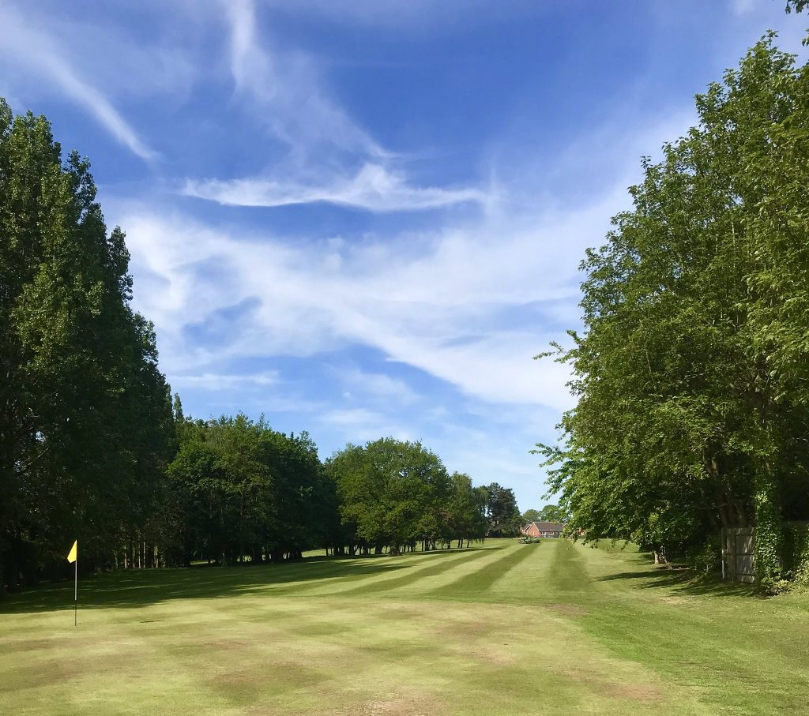

Contents

- Welcome to Pastures Golf Club
- Club history
- Course record
- Social club
- Membership benefits
- Registering on the Pastures website
- Drop-in Zone (DIZ)
- Volunteering at Pastures
- Golf lessons at Pastures
- How the club is managed
- Good manners on the course
- Dress code
- Club competitions
- Getting your first handicap
- Registering with “My England Golf”
- Booking a tee time
- Speed, safety and etiquette
- General safety
- Car parking
- Pastures newsletter
- Local and winter rules
- Official course and slope rating

Welcome to Pastures Golf Club

We are very pleased to welcome you as a member of Pastures Golf Club and hope you will have a long association with the Club, enjoying quality golf and good company in pleasant surroundings.

This information booklet is intended to help you get the most out of your membership and to highlight the facilities and activities available to you as a member of the Club.

We want to make all of our members feel welcome.

If you have any questions or any suggestions to make, please speak to a member of the committee or call into the Drop-In Zone (DIZ).

Thank you for joining Pastures Golf Club, which we like to think of as a welcoming and friendly club. Hopefully you will enjoy your golf here.

Club history and background

Set in the grounds of the old Pastures Hospital, the golf course was originally built for the patients and employees at the hospital. You may notice the other sporting areas adjacent to the Social club that accommodate football, cricket and archery.
Pastures Golf Club as it is now, was established in 1969, and is a well-established course built on meadowland, complete with mature trees. A community of new houses has grown up around the course and many of our members live on the Pastures estate.
It is a great setting for golf, with great views as you walk around the course. All the fairways are tree-lined, making it a course to challenge any golfer. Taking full advantage of the extensive, undulating meadowland in the area, this nine-hole course is a true test of ability and, for those whose game needs a bit of extra work, there is a practice area, a practice net, and a putting area to fine-tune the various aspects of your game.
In 1969 Tour Pro Max Faulkner opened Pastures golf course. Little did he know that the course par of 64 would not be beaten in the 50 years following, with no round below par until 2023, when our own Richard Essex achieved that feat, winning the 2nd Pastures Open into the bargain with a one under par score.

The Pastures Open will be back in 2024 – you are welcome to join either the scratch or handicap events

Rick Shiels Tour Pro Challenge
Rick Sheils has his own golf blog on YouTube. He became aware of Pastures Golf Club in 2021 and was captivated by the history of the course, where nobody had ever beaten par. He contacted one of the golf pro’s he knew from the European tour and arranged for James Robinson to come to the course and see if the record (1 over par at that time) could be broken. The challenge was unsuccessful however, undeterred, Rick brought another tour pro, Ryan Ruffels, to Pastures to take up the challenge, which again was unsuccessful.
Rick Sheils is now planning to bring another tour professional to the course in 2024, and there are a lot of Pro’s interested.
Social Club facilities

The social club is immediately opposite the golf course car park. It opens in the evening as a bar, but the social club also hosts a number of other functions and is open for public use and booking. All the golf club functions are presently held at the social club. These include:

- Drinks on Wednesday lunch time after Seniors competitions
- Presentation evening for prize giving throughout the season
- Meals and presentations after inter-club matches
- Annual Presentation evening for the club
- Annual Presentation dinner for the Seniors’ section
- Annuals general meetings for the club and seniors
- Captain’s Drive-in to start the season
- Captain’s Drive-out to end the season

A great place to wind down after a round of golf.

The Pastures Golf Club is a popular golf club with an active membership. We’re committed to welcoming members from all backgrounds.
Membership benefits include:
- Very competitive membership fees
- Playing rights of the course according membership category
- Access to the online booking system where games can be arranged up to 14 days in advance.
- Entry to Club Competitions
- Handicap management
- Full use of practice facilities (driving range, practice net and putting green)
- Home and away team matches against other clubs
- Membership includes fees for both the Derbyshire County Golf and England Golf unions.
- Discounts on certain drinks at the Mason’s Arms Mickleover on production of a membership card.
- All Members and their guests can enjoy the social functions, which are regularly organised by the Club.
- Access to and management of an official WHS handicap.
- Access to play in open competitions, club competitions, regional leagues and alliances.
- Access to a range of competitions and social golf on a regular basis.
- Access to a sport that can have a positive impact on your health.
- Access to coaching with a qualified PGA Professional.
- Access to a thriving club, with a sense of belonging and opportunity to make new friends.
- Access to an activity the whole family can participate in.
All Members and their guests can enjoy the social functions, which are regularly organised by the Club.
Registering on the Website
To obtain access to the members’ section of the Club website as opposed to the publicly available information, new members will be sent a logon username and password following payment of fees.
Click on ‘Register’ at top right and provide the information requested. It is important to ensure that your email address is the current one you are using and have given to be added to your details in the members’ record system before trying to register on the website.

The Drop-In Zone (DIZ)
The Drop-In Zone is open to all players, and you can purchase drinks and snacks, obtain scorecards, register your game for online handicap management, enter club knockout competitions and meet other members, ask for advice, gather information on what’s happening at Pastures. There are also toilets adjacent to the DIZ.
Joining a new course and meeting members can sometimes be daunting, so we’d like to encourage you to introduce yourself via the Members chat section on the club website to meet other members.
However, you can’t beat just calling in to the DIZ and talking to members who are sitting around drinking coffee. Stay and have a chat and you will soon be on the way to making lots of friends at the club.
Club Polo Shirts
If you want to look cool when out on the course then you can also order club polo shirts with the club crest from Prestige Embroidery at a very reasonable price which includes the embroidery. The company is situated in Derby Centre, at 8 Monk Street. Call them on 01332 203850.
Volunteering at Pastures
Volunteers play a vital role in the organization and management of Pastures Golf Club. Furthermore, we think volunteering is an excellent way of making members feel more included and keeping you fully up to date with the development of the Club.
We also believe that we have a membership that has a huge variety of transferrable skills which can be called upon to support the club. To date, we have identified two categories of volunteering, Manning the Drop-in Zone and Course Maintenance (there will be more to come).
What skills do you have that would benefit the club? Electricians, Plumbers, Mechanical Engineers, Information Technology, Event Organisation, Marketing, Fund Raising, there are so many more…
All that we want at this stage is for you to register as a volunteer, we will then have a live register of volunteers who can be called upon to make the best possible use of your skills.
Pastures Golf Club is on the way up, come, and be part of an enthusiastic team.
We hope this booklet gives you some valuable information about the club and remind you that updates to what is happening can be found on the website and via Twitter. The management team will also be only too willing to assist with any queries via the contact section on the website or emailing us at info@pasturesgolfclub.co.uk.
Happy golfing!
On behalf of Pastures Golf Club Management Team

Golf lessons at Pastures

The DIZ can put you in touch with a PGA Professional who gives lessons at Pastures Golf Club. All skill levels and abilities are catered for.
Special rates available to Pastures members

How Pastures Golf Club is managed.

All organisations need some management structure to ensure that the interests of the organisation are protected and that steps are constantly being taken to improve the service.

Pastures is no different. We have directors, a management committee, green-keepers, and a host of other roles largely carried out be volunteer members.
The captain, vice-captain and seniors captain are invited onto the committee each year. All other places are subject to confirmation by members at the Annual General Meeting, which is normally held in February. Where there are vacant spots on the committee due to members standing down, members can nominate new committee members at the AGM.
The Directors and Committee are responsible for:
- Organisation of Club golf competitions and matches.
- General Rules and Procedures.
- Development of resources
- Rules for competitions.
- Disciplinary matters.
- The condition and management of the course
- Management of the Greens staff
- Financial management of the club

Details of the current directors and committee members is available from the DIZ.

Annual General Meeting.

This takes place in February and we encourage all members to attend. This provides an opportunity for members to ask questions. offer suggestions and make a positive impact on how the Club is managed.

The club is run as a not-for-profit enterprise which allows for a programme of continuous improvement of the course.
The members’ section on our website provides you with access to a lot of information about competitions, Club business etc.
You can book into competitions online via the booking section on the members website. If this is a formal club competition then you will need to register using How Did I Do, either on your phone or on the computer in the DIZ. If you don’t know how to do this then any established member should be able to show you how to complete this task. After the competition you will need to re-enter the Howdidido site to input your scores.
The Club now requires members to book tee times for practice or social rounds through our on-line booking via the Pastures website. We have decided to continue this practice so that we know who is on the course at all times for safety and security reasons.
Course availability can be found on the calendar on the website.
Good manners on the course (often referred to as “golf etiquette”)
Members, and their guests, are requested to play at a reasonable pace. A standard measurement for a four-ball at Pastures is one hour and 45 minutes for 9 holes. Check your time after 9 holes. If you are going slower than this then you will potentially be holding up faster groups.
We know that not all golfers play at the same speed, or play to the same standard, but if you notice that there are always people waiting on the tee for you to finish the hole then you either need to speed up your game or wave them through. Just go to the side of the fairway and let them take their shots. Once they have come past and completed the hole then you can re-commence your round.
Pastures is quite a compact course, and there are areas where your shots can travel perilously close to players on other holes or greens. Please be mindful of this. If you feel that your shot is travelling towards other players then please shout “FORE” as loud and as quickly as you can. This will alert all players in the vicinity who will then try to take evasive action behind a tree.
Please ensure you display your members bag tag whilst playing, if you do not have a bag tag yet, please contact the DIZ staff and they will supply you with a new tag.
Dress Code on the course
As with all respected Golf Clubs, Pastures has a code of dress which MUST BE ADHERED TO when playing on the Course.
Players should wear:
- Polo shirts,
- smart jumpers,
- sweat shirts,
- smart casual trousers or
- tailored shorts and
- golf shoes.
- At times of exceedingly dry conditions, trainers may be worn and a notice to that effect will be displayed in the Drop-In Zone.
- Juniors may wear SMART trainers.
- Ladies may also choose to wear blouses and skirts.
PLAYERS WILL NOT BE ALLOWED ACCESS TO THE COURSE IF WEARING:
Jeans, shell/track suit bottoms/tops, everyday shoes or football style shorts.
FAILURE TO FOLLOW THE DRESS CODE WILL RESULT IN YOU OR YOUR GUEST BEING ASKED TO LEAVE THE COURSE.

Balls that go out of bounds in housing areas
All Golfers are reminded to report any incident where a ball is hit into the adjacent housing development, to “The Drop-In-Zone” and record it in the contact form on the club website, or by emailing us at info@pasturesgolfclub.co.uk Your Green Fee includes some insurance but all players are advised to ensure that they have adequate personal cover.
Local safety rule
When playing the course and approaching the 4th green please be aware of players teeing off on the 7th hole to the left. Please give them priority and allow them to play before you putt. If players are approaching the 9th green when you are about to commence your round please ask if they are carrying on their round and allow them to do so before you start play.
Club Competitions – all members can enter, regardless of standard
There are competitions taking place all year round at Pastures Golf Club.
The main club competitions are run on Sundays every week throughout the golf season. These competitions include:
- Stableford competitions – this is a points scoring game played in 2-ball, 3-ball or 4-ball format
- Medal Competitions – This is a more exacting game where every shot is counted and your handicap is taken off the total number of shots.
- Major competitions where trophies are awarded
- There are prizes awarded each week and presentations take place periodically throughout the season. You must attend the presentation or give your apologies for non-attendance, or your prize may be withdrawn.
Throughout the week there are other competitions taking pace. These include:
- The Tuesday club – a Stableford match format where prizes are won weekly and points are awarded towards a league table. There is a prize for the overall winner. This is a very popular competition in Summer
- The Seniors Section hold their weekly competitions on Wednesdays. These are open to any member over 50 years of age. Prizes are awarded weekly. These include Stableford, Medal, Texas Scramble, Par competitions, and there are major competitions where trophies are awarded.
- The Seniors also have one or two matches against other clubs each month. These are usually on Tuesdays or Thursdays. Each match is followed by a meal. It’s a great team experience and you get to play at other clubs as well.
- Club knock-out competitions. There are individual knock-out competitions for both the main club and the Seniors. There are also doubles knock-outs for the main club and seniors, and then there are what are known as “scratch” knock-outs where all players play off a zero handicap (not for the faint-hearted).
- The Winter League runs from the end of the summer season to beginning of the next summer season (October to March). You play off your club handicap but the only adjustments are made if you come first or second. There are weekly prizes as well as a prize for the overall winner of the league. This is open to all members and you can play once or twice between Friday and Sunday each week, the best score counting.
Other Annual competitions
- The Captain’s Away Day is an annual competition played at a club of the Captain’s choosing. Great fun with prizes and a meal.
- Senior Captain’s Away Day. Same as above but only open to players who are 50 years old or older.
- Captains V Presidents. This is a match made up partly of present and previous Captains and Presidents and then other members filling in the other places. 12 players per team at a course of the President’s choosing. More prizes available.
- The Pastures Open. Open to all members with big prizes for best scratch performance and best performance with a handicap allowance. There is an even bigger prize for anybody who breaks the course record. Great fun to play in and it attracts a lot of outside interest from low handicappers and professionals.

Inter-club competitions.
There are a number of competitions that Pastures play against other teams, which are open to all members (between 4 and 8 players per team). These include:
- The Scratch League – played against 5 teams home or away.
- The Handicap League – played against 5 teams home or away

There are also a number of other regional and national competitions that we enter teams into. These teams are often run or at least organised and delegated by the club captain. So, if you are interested in a really competitive challenge then speak to the captain or vice-captain, or send a message via the club website or on info@pasturesgolfclub.co.uk

Getting your first Handicap
Handicaps can be obtained by playing either 3 x 18-hole rounds or 6 x 9-hole rounds with a member who has a playing handicap marking the card. You can play these qualifying games off white, yellow or red tees, as long as you stipulate which tees you have used on the card.
Once you have completed each card, you must ensure that all the details are completed and that you have written “handicap card” on the card with a number. So, if this is your second card then you write “handicap card number 2” on the card and place it in the competitions box in the DIZ. It is also advisable to take a photo of the card on your phone, just in case cards are misplaced.
Once you have joined the club, you will be registered on HowDidIDo by the club, and a CDH (Central Database of Handicaps) number from England Golf will be obtained for you. You will retain this throughout your amateur career and Pastures will manage your handicap throughout your time with the Club.
“HowDidIDo” is a website that we use to record all club competition scores. You register on it before you start your round, either on your phone or on the computer in DIZ, and then you record your scores after the round. Once you are registered with My England Golf, you can track the changes in your handicap from week to week.
If you already have a handicap or have had a handicap at another club you should provide us with details including your CDH number.
If you wish Pastures to manage your handicap you must ask your previous club to give you a copy of your handicap certificate (which you should then give to our Handicap committee) and ask your previous club to delete you from their handicap system.
If you have joined Pastures as a second club and you wish your handicap to continue to be managed by your other club this can be done and you will be treated as an AWAY player at Pastures – but you must ensure that you notify us regularly of your scores and handicap revisions.
From November 2020 golf handicaps have been awarded based on the World Handicap System under the auspices of the GB&NI association, CONGU who regulate the laying of competitive golf in this country.
England Golf will take a stronger role in managing WHS Handicaps and have created an on-line platform which members are invited to register onto and check their handicap developing once they have been awarded one and they have their CDH number.
My England Golf sign-up
Those with existing handicaps will have a Handicap Index automatically generated based on their best 8 scores from the last 20 games. If fewer than 20 scores are available to calculate a handicap Index, a sliding scale is used.
For new golfers to gain their handicap Index, they must submit a minimum of 54 holes (using any combination of 9 and 18 holes on a measured course and by another player).
For the purposes of the initial award of a Handicap Index two 9-hole scores are combined. The maximum hole score for new golfers is par +5 strokes, and holes not completed or scoring above this will be adjusted to par + 5.
If you are having problems playing sufficient competitions you can pre-register a supplementary score round, entering the scores on completion.
With WHS, players are encouraged to take every opportunity of entering scores for as many rounds as possible which will reflect closely their playing ability and level.
Booking a tee time
All games have to booked via the online booking system.
We have opened this facility to allow members to invite guests on their behalf. Guest green fees are provided at a discount rate to members.
Booking slots are in 15-minute intervals and players are asked to tee off on the quarter hour i.e., on the hour, quarter past, half past etc and not sometime within the 15-minute slot.
The system allows you to join others or allow others to join you.

The Spirit of the Game

Golf is played, for the most part, without supervision of a referee or umpire. The game relies on the integrity of the individual to show consideration for other players and to abide by the rules. All players should conduct themselves in a disciplined manner, demonstrating courtesy and sportsmanship at all times, irrespective of how competitive they may be. This is the spirit of the game of golf.

Code of conduct

Respect your fellow golfers.
Be courteous at all times.
Play fair and honest.
Listen, learn and try to improve.
Practice hard.
Look smart, be polite and stay healthy.
Treat others as you expect to be treated yourself.
Be a role model to juniors.

Etiquette
In golf the way you behave on and off the course is very important. Good behaviour is called ‘etiquette’. It is important for three reasons:

To make sure you are safe
To make sure you look after the course
To make sure you don’t hold up players behind you.

Speeding up your round and looking after the course

No more than three minutes is allowed to search for a ball. Be ready to call through if you can't find your ball within two minutes and proceed by enforcing the golf rules governing the conditions under which your ball was lost. If more than one ball needs to be found, split up and search for all the balls at the same time
If you hit a ball that you think may be hard to find, or it may be out of bounds, please hit a provisional ball to save having to walk back if the first ball can’t be found
Go to your ball and get ready to hit your next shot as soon as it is feasible; i.e., not impeding another player's shot or endangering yourself. Don't always wait for your golf partner to play before going to your ball
Short hitters to tee off first
Walking briskly between shot
Leaving your golf bag, buggy or cart strategically placed to side of the green nearest the next tee.
Buggy users should be particularly aware of the extra time taken in sharing a buggy and look for ways to speed up play, for example, move ahead of walkers to look for possibly lost balls, try to position the buggy for easy access when leaving the green to reduce the number of times that you have to get in and out.
Always conduct yourself in a disciplined manner. Try and demonstrate courtesy and sportsmanship at all times, irrespective of how competitive you may be - this is essentially the SPIRIT OF THE GAME
On the Green
When you reach the green, move to your ball and repair any pitch marks. Where possible, line up your putt prior to your turn to putt
If your ball needs to be marked, then do it as quickly as you can. Anticipate the requirements of your fellow player. Move back and line up your putt
Except in match play, and where you will stand on someone else's lie, when you start putting, continue until you have holed out. If playing a par or Stableford event and you can no longer score on that hole, pick up your ball and let others continue
The first player to finish putting should take control of the flag and be ready to replace it in the hole when the final player has completed the hole
Players should proceed to the next tee without delay. The following group should be waiting to play their approach shots, so the path taken to the next tee should be borne in mind. Think ahead; leave your cart or buggy in a place where you won't be hindering the following players
Cards should be marked as quickly as possible after completing the hole, but it is best to mark the cards at the next tee. Please mark your card when it is not your turn to play and remember, at all times your place in the field is immediately behind the group in front and not in front of the group behind.
Ready golf
With more members keen to play it is important that we all address ‘pace of play’ issues. A simple change is to play ‘Ready Golf’ on the course and on the putting green. Allowing players to play when they are ready to do so, rather than adhering strictly to the “farthest from the hole plays first” stipulation should be encouraged, except during match play games. Examples of ready golf include playing when someone in your group is assessing a tricky shot, shorter hitters playing first if longer hitters have to wait and hitting a shot before helping someone to look for a lost ball. Another is putting out as long as you are not on someone’s line.
Being ready to play should be very easy and considerable time will be saved if players do these things efficiently. For example, if each player in a four-ball that shoots 80 each takes an average of five seconds less to play each shot they will save over 26 minutes (80 shots x five seconds x four players).
We would like our members to make a point of applying this at Pastures.

Pitch Marks & Divots
We pride ourselves on the condition of our greens throughout the year. However, such playing surfaces can only be maintained if all golfers repair their pitch marks on the green.
We would ask you to not only repair your pitch marks, but ensure that all players within your group adhere to this policy – and look for another one to repair – if we all do that, we will make a big dent in the problem.
Golfers are also responsible for the repair of all divot marks. If you make a divot, please replace it in its original location.
On tees with soil boxes – make sure you cover your divot mark.

General Safety Points

Always consider your safety and that of your playing partners, fellow players, greens staff and members of the public.

You are responsible personally for any injury or damage that you cause and you should have personal liability insurance sufficient to cover any injuries to yourself, fellow players, members of the public and damage to property.

DO NOT play a shot if fellow players are within range especially if visibility is impaired.

DO NOT play a shot if greens staff are working ahead – wait until they have waved you on and stood clear.

Observe the safety instructions for Buggies on the course.

Always remember that golf is dangerous if certain rules are not observed.

Be aware of other players and where they are in relation to you.

Stand a safe distance from anyone swinging their club because they may not know you are there. Never step in front of the hitting line or tee.

Make sure you have room to swing your club. Never swing a club towards someone else.

Shout ‘’FORE!’’ immediately if you think your ball may hit someone.

Duck and cover your head if you hear ‘’FORE!’’ shouted at you and face away from where the shout has come from.

Above all, please ensure that all golf course policies in relation to health & safety and adverse weather conditions are always followed.

If you follow these tips, you are more likely to enjoy your round of golf and so are other golfers.

Car parking
Park with consideration
At times when events are also on at the football club and social club there may be congestion.

Newsletter - This is a way that the club communicates with members. It comes out every six weeks or so, and has a number of regular features, as well covering events and results at the club, interviews with committee members and new members. Updates from the greenkeepers regarding the state of play at the course and any new developments. It comes to you via the announcement function on the website. You will receive it as an email.
Winter rules

Members may be requested to carry clubs to ease the damage to the course, particularly in wet weather. If you need to use a trolley then try to keep the weight of your bag to a minimum.

Notices on course condition will be seen on the board as you approach the DIZ, on the sign in sheet and will also be sent out via the announcement function and email.

Local Rules

All local rules are on the back of our scorecards. If any amendments are needed, they will be posted on the website or on the notice board near the DIZ

Official Slope/Course Rating
Course Rating represents the difficulty of a golf course for a scratch golfer (0 Handicap Index), calculated to the nearest 0.1.
Slope Rating represents the relative difficulty of a course for a bogey golfer (20 to 24 Handicap Index) compared to a scratch golfer.
A course with long carries, narrow fairways, lots of hazards and thick rough will have a high slope rating because these features are more of a challenge to bogey golfers.
Slope Rating can be anywhere between 55 and 155. 113 is the neutral value that is used in handicap calculations. The GB&I average Slope Rating is 125. Pastures Golf Course ratings are:
Tees | Gender | Length/Par | Course rating/slope rating | Bogey Rating | Front 9 | Back 9
White | Men | 4940/64 | 65.1/114 | 86.3 | 32.7/112 | 32.4/116
Yellow | Men | 4615/64 | 63.9/113 | 84.9 | 31.9/114 | 32.0/112
Red | Women | 4645/68 | 68.1/110 | 93.9 | 34.0/108 | 34.1/111

For more information about golf see “Pastures Golf Course: Golf Terminology and other information”
Rules of golf booklets are available at the DIZ
The R&A rules can also be downloaded as an app.

